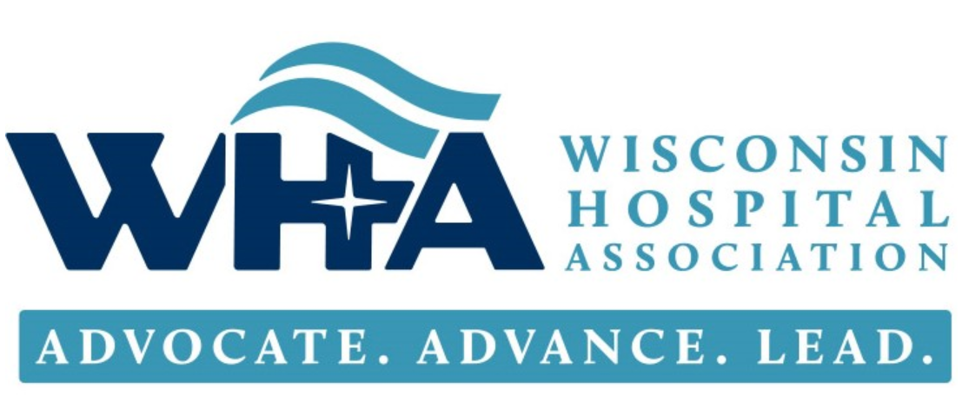
WISCONSIN HOSPITAL ASSOCIATION – STROKE SYSTEMS of CARE COLLABORATIVE AGENDA
Community Awareness and Pre-Hospital Care
Thursday, February 4, 2021 | 10:30am – 12:00pm
Virtual | Microsoft Teams | Click here to join the meeting
Call in (audio only) +1 608-338-1404,,568632211# Phone Conference ID: 568 632 211#

Program Mission: To provide support and collaboration to Wisconsin hospitals to implement stroke systems of care (SSoC) that meet standards for achieving Acute Stroke Ready Hospital (ASRH) criteria for improved stroke patient outcomes.
Learning Objectives
At the end of this webinar, Stroke Teams will be able to:
- Summarize resources for public education around stroke symptom identification and early 9-1-1 notification
- Recognize the signs of a Stroke – BE FAST Bella
- Examine EMS field assessment data (documentation of LKN- Last Known Normal), transit time, and communication improvement strategies, including a feedback loop for EMS
Topic | Presenter | Time
Welcome and Agenda Overview | Jill Lindwall, MSN, RN, CPHQ; Clinical Quality Improvement Advisor  Wisconsin Hospital Association | 10:30 – 10:35
Public Education - Stroke Symptom Identification and Early 9-1-1 Notification | Carrie Rupert  Director of Clinical Services  Bellin Health Oconto Hospital and Clinics | 10:35 – 11:10
BE FAST Bella | John Bowser, PhD, Wisconsin Coverdell Program Director  Wisconsin Department of Health Services | 11:10 – 11:20
EMS Actions in the Field When Caring for a Suspected Stroke Patient | Kerry Ahrens MD, MS  Emergency Medicine BayCare Clinic  Medical Director Aurora BayCare Urgent Care  Medical Director Oshkosh Fire Dept  Co-Chair Wisconsin Stroke Coalition  UW Medflight Physician  UW School of Medicine, Clinical Assistant Professor | 11:20 – 11:55
Next Steps | Jill Lindwall | 11:55 – 12:00
Adjourn | All | 12:00

Continuing Conversation: This is an ‘all teach, all learn” format. Please come prepared to actively contribute to the discussions.

