Hospital Member Social Media Toolkit
National Hospital Week

National Hospital Week (May 11-17, 2025) is an opportunity to highlight Wisconsin’s hospitals, health systems and health care workers and the innovative ways they strengthen communities across the state.

During the week, WHA will concentrate its social media messaging on celebrating hospitals and health systems and recognizing the strong communities they create. We invite you to join us in this celebratory campaign. Please incorporate the hashtags #WIHospitals and #MoreThanHealthCare and tag WHA in your posts for maximum reach and engagement.

The following are WHA’s social media channels, a suggested social media post and newsletter content for your hospital or health system and accompanying graphic templates.

WHA Social Media Handles
- Facebook: Wisconsin Hospital Association
- Instagram: @WIHospitals
- LinkedIn: Wisconsin Hospital Association
- X: @WIHospitalAssn

Campaign Hashtags
- #MoreThanHealthCare (Wisconsin-specific)
- #HospitalWeek (posts may receive national viewers or shares from the American Hospital Association (AHA).

Sample Social Media Post for WHA Hospital Members
- It’s National Hospital Week – and at [Hospital Name], we’re proud to celebrate all the ways we’re More Than Health Care! From creating jobs to supporting education, youth sports and wellness initiatives (these are just examples, but you could add your own initiatives)], our impact reaches far beyond the bedside.
Join the celebration: www.wha.org/Hospital-Week
#MoreThanHealthCare #WIHospitals

Sample Newsletter Content
- In honor of National Hospital Week, May 11–17, [HOSPITAL] is proud to celebrate the many ways we’re More Than Health Care in the [CITY] community! From [INITIATIVE] to [INITIATIVE], our impact extends far beyond the bedside. In 2024 alone, Wisconsin hospitals provided more than $2.3 billion in community benefits and charity care, while employing over 110,000 people statewide. Together, we’re building a healthier, stronger [CITY]. Learn more about Hospital Week at wha.org/hospital-week.

Editable Canva Templates
We invite you to use our designed Canva templates. Click here view the template and scroll to see all designs. Click File > Make a Copy. Then, customize the graphic with an image or logo that reflects your hospital or health system supporting Hospital Week.
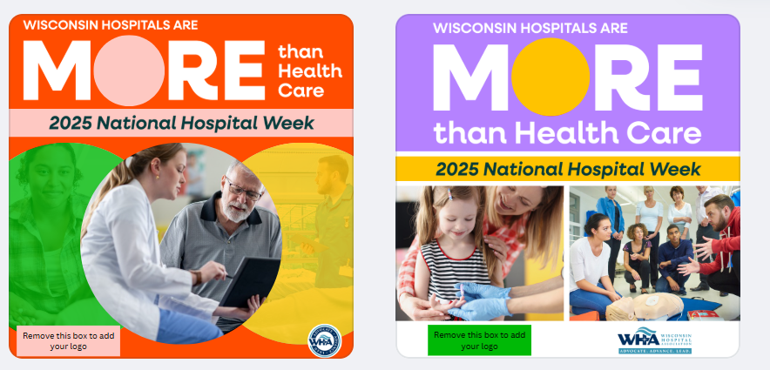
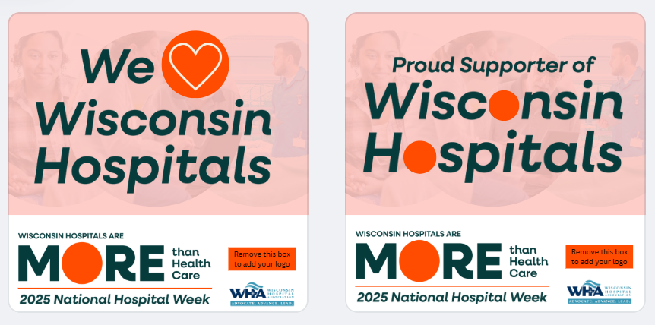
For assistance with resizing or accessing the graphics, contact WHA Marketing Communications Manager Katelyn Hopman.

