Lawmaker Social Media Toolkit
National Hospital Week

National Hospital Week (May 11-17, 2025) is an opportunity to highlight Wisconsin’s hospitals, health systems and health care workers and the innovative ways they strengthen communities across the state.

During the week, WHA will concentrate its social media messaging on celebrating hospitals and health systems and recognizing the strong communities they create. We invite you to join us in this celebratory campaign. Please incorporate the hashtags #WIHospitals and #MoreThanHealthCare and tag WHA in your posts for maximum reach and engagement. We encourage you to also keep an eye out for local hospital posts to echo their messaging.

The following are WHA’s social media channels, a suggested social media post for your use and accompanying graphic templates.

WHA Social Media Handles
- Facebook: Wisconsin Hospital Association
- Instagram: @WIHospitals
- LinkedIn: Wisconsin Hospital Association
- X: @WIHospitalAssn

Campaign Hashtags
- #MoreThanHealthCare (Wisconsin-specific)
- #HospitalWeek (posts may receive national viewers or shares from the American Hospital Association (AHA).

Sample Social Media Post for Lawmakers
- In recognition of National Hospital Week, I’m proud to support the outstanding work of @(Hospital Name) and @(Hospital Name) in my district.
Thank you for the vital role you play — both within the hospital and throughout the community. You are truly More Than Health Care.
#MoreThanHealthCare #WIHospitals

Editable Canva Templates
We invite you to use our designed Canva templates. Click here view the template and scroll to see all designs. Click File > Make a Copy. Then, customize the graphics with an image that reflects you supporting Wisconsin hospitals.

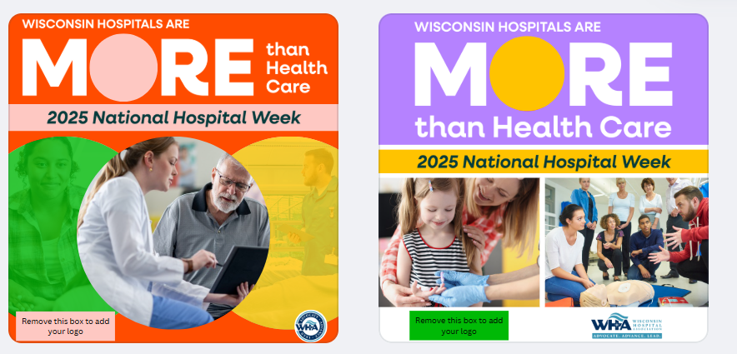
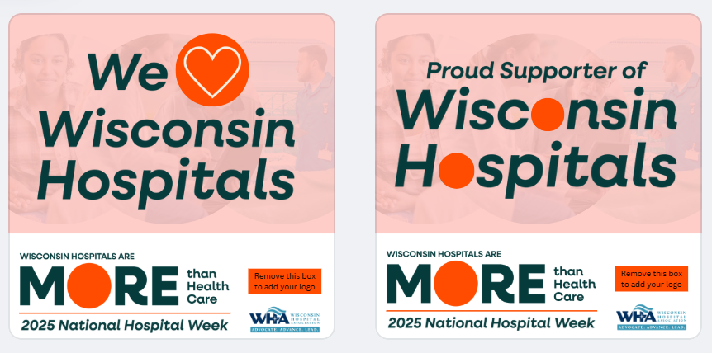

For assistance with resizing or accessing the graphics, contact WHA Marketing Communications Manager Katelyn Hopman.

